**Module 4 Lab 1: Protecting Resources**

Anudeep Anisetty

Information Technology, Arizona State University

IFT 554: Middleware Prog & Database Sec

Dinesh Sthapit

March 3, 2024

**Module 4 Lab 1: Protecting Resources**

1. **Screenshot Requirement**: Terminal or command prompt showing that the application has been stopped.

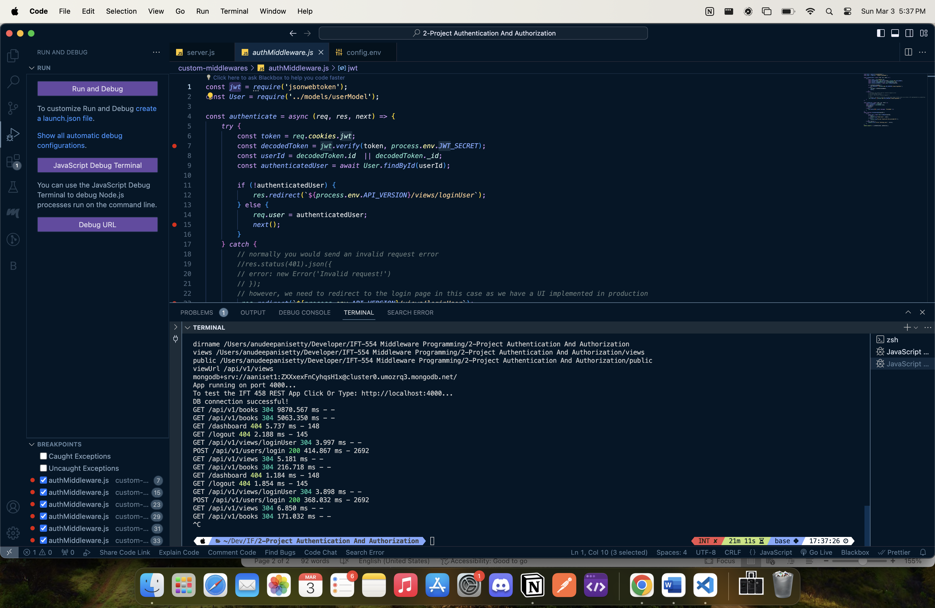

1. **Screenshot Requirement**: Terminal showing successful installation of dependencies.

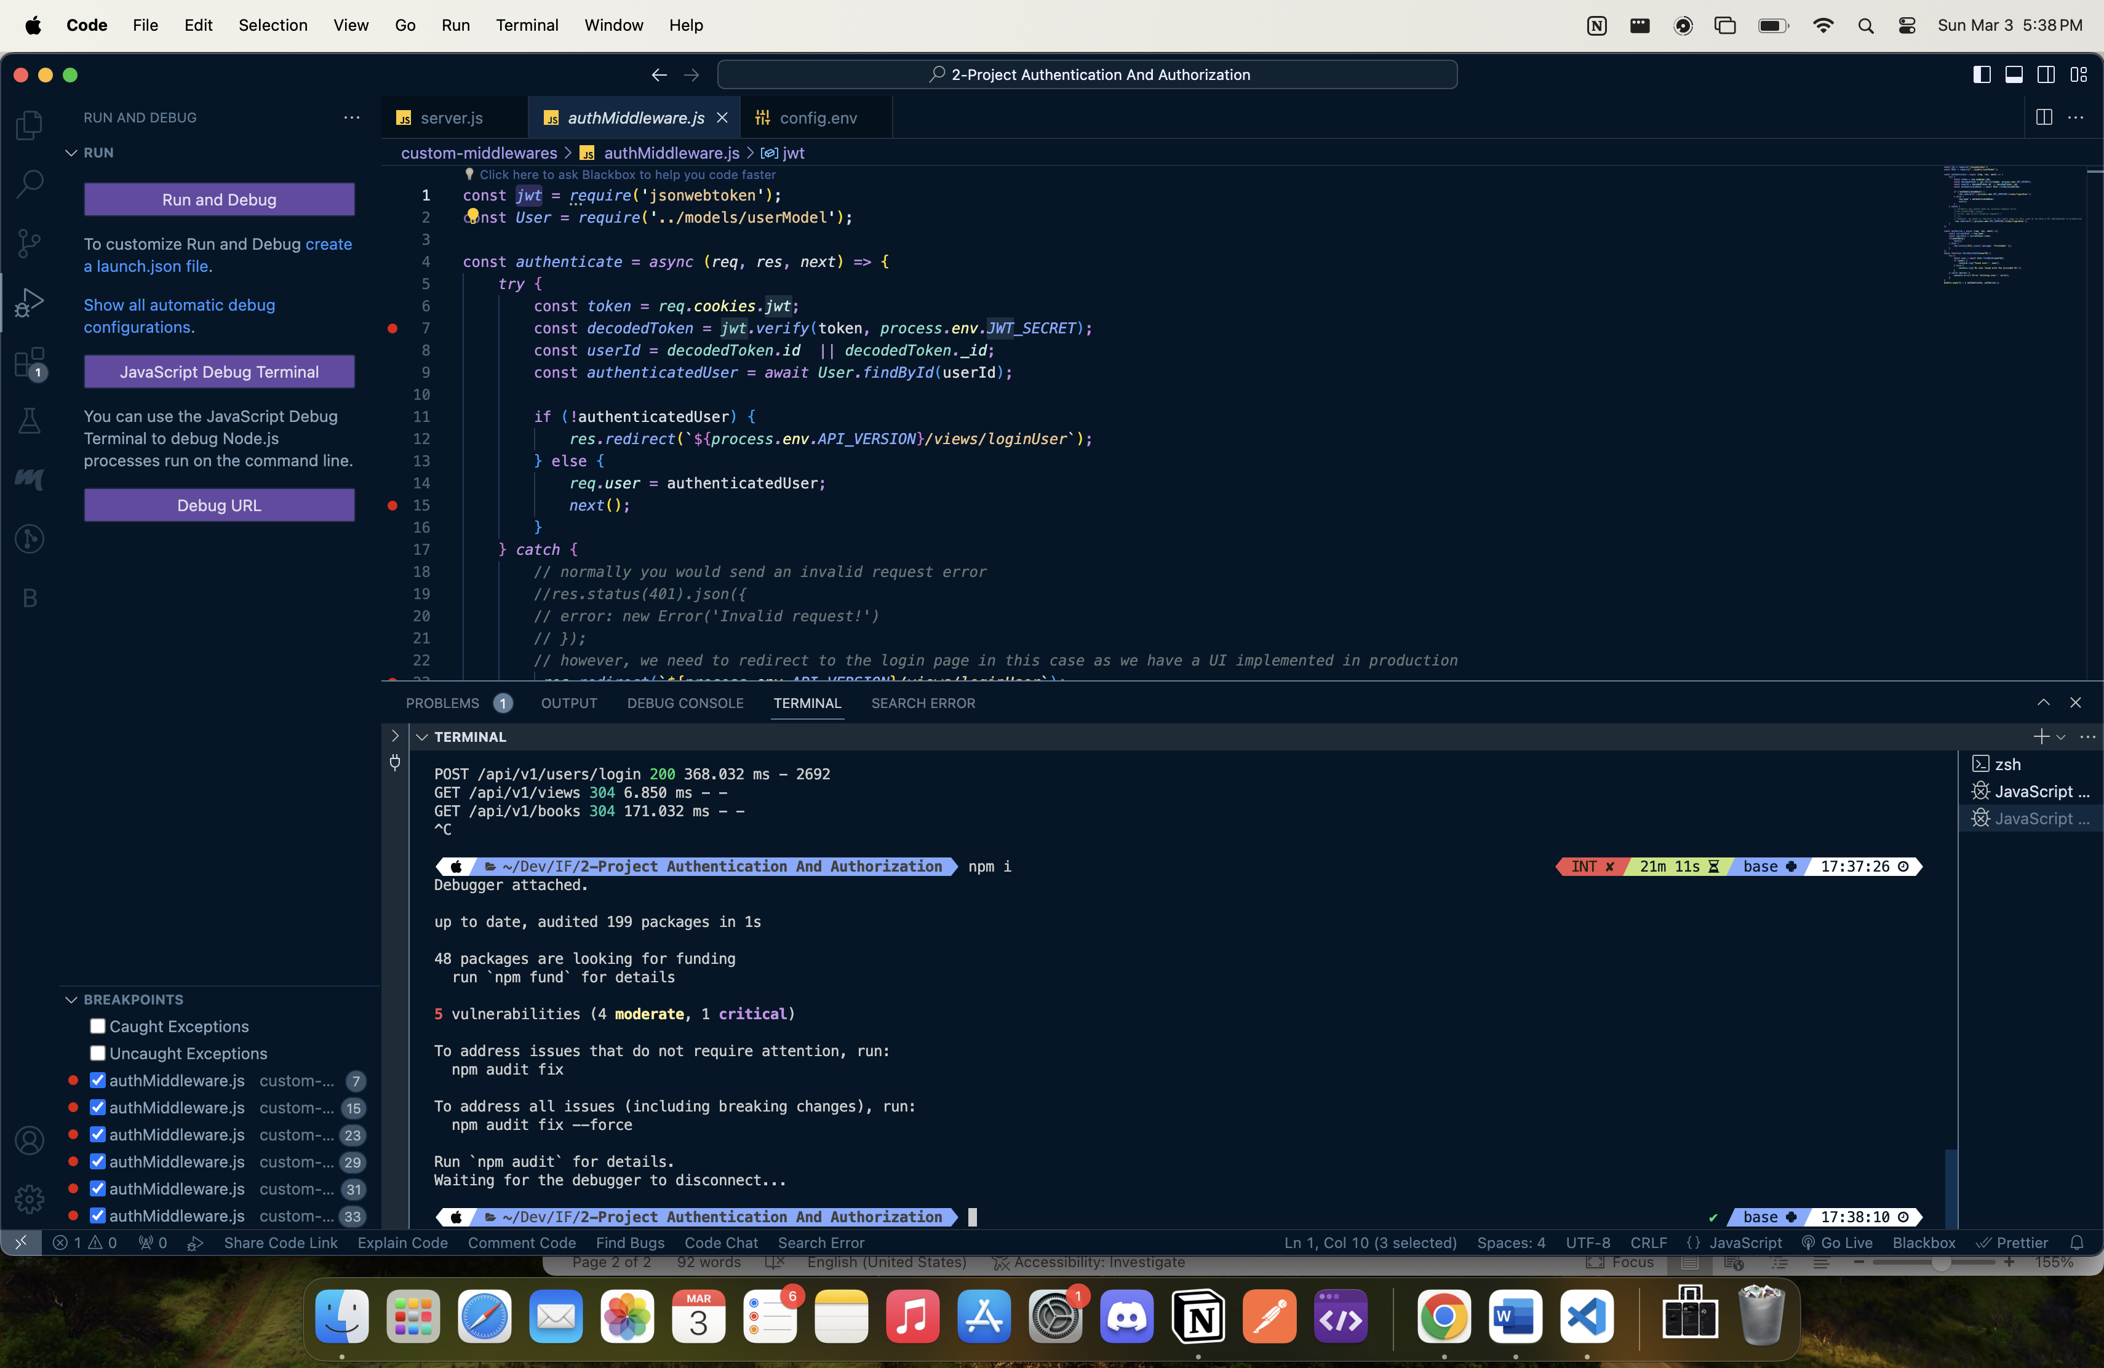

1. **Screenshot Requirement**: The EJS file code and its rendered UI in the browse.

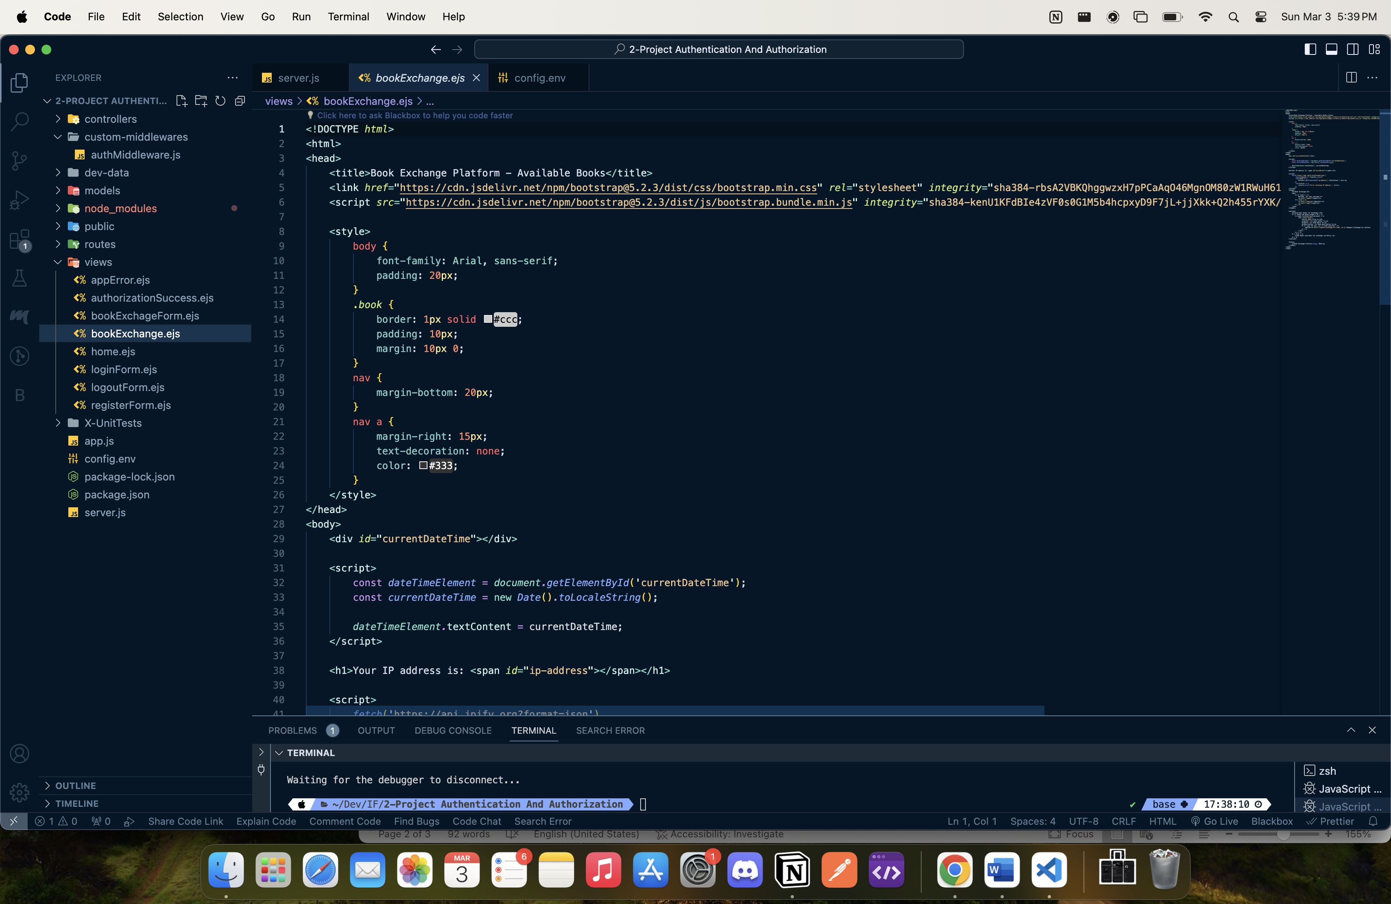

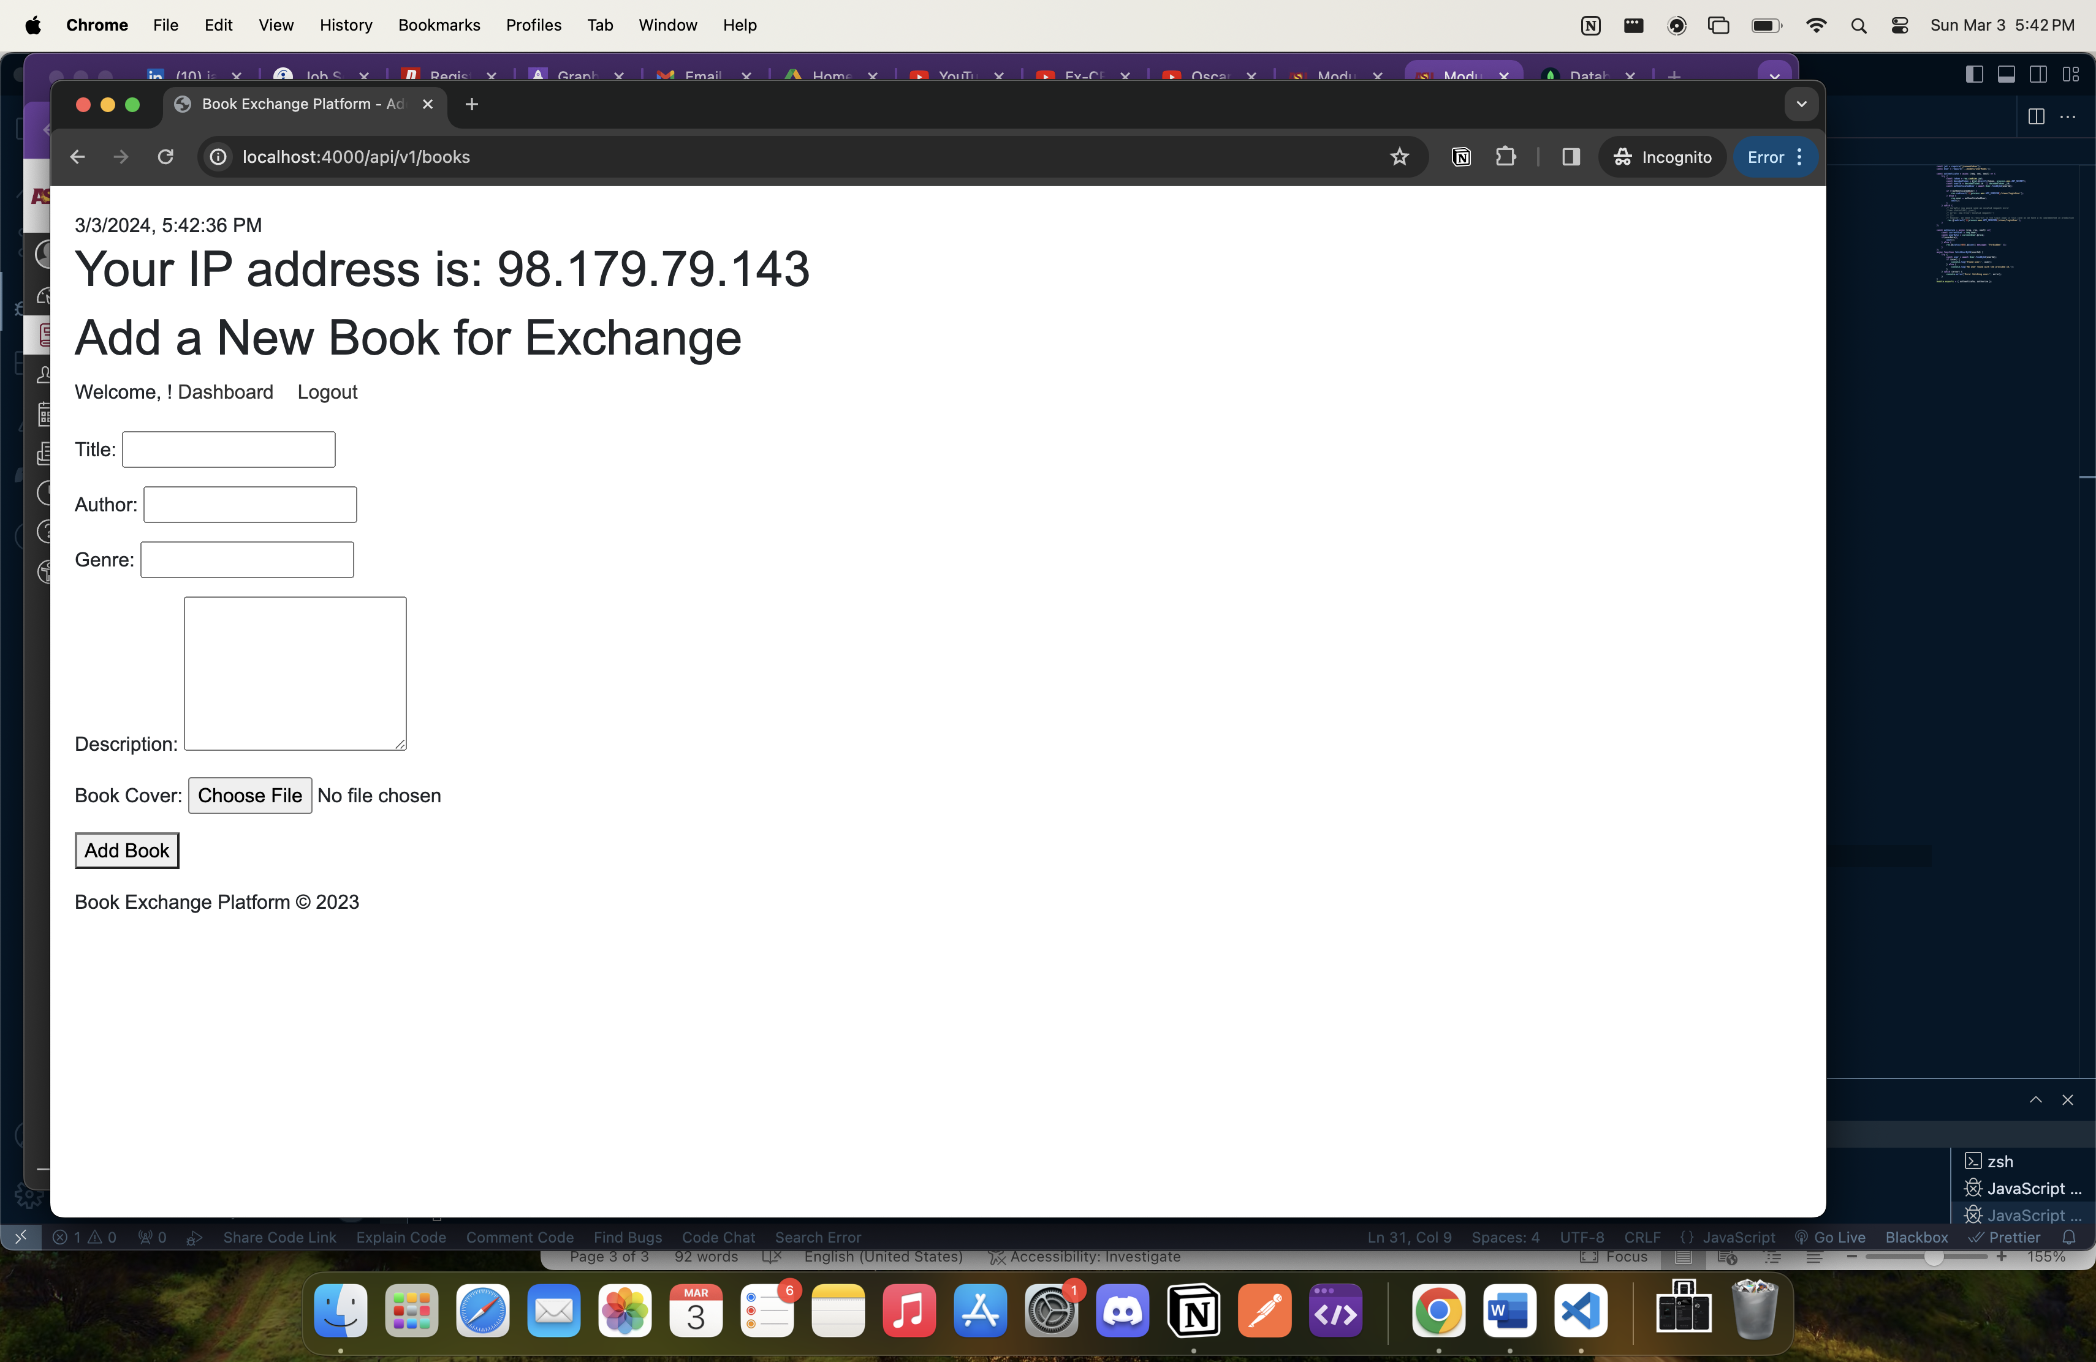

1. **Screenshot Requirement**: The installed REST Client extension in VSCode.

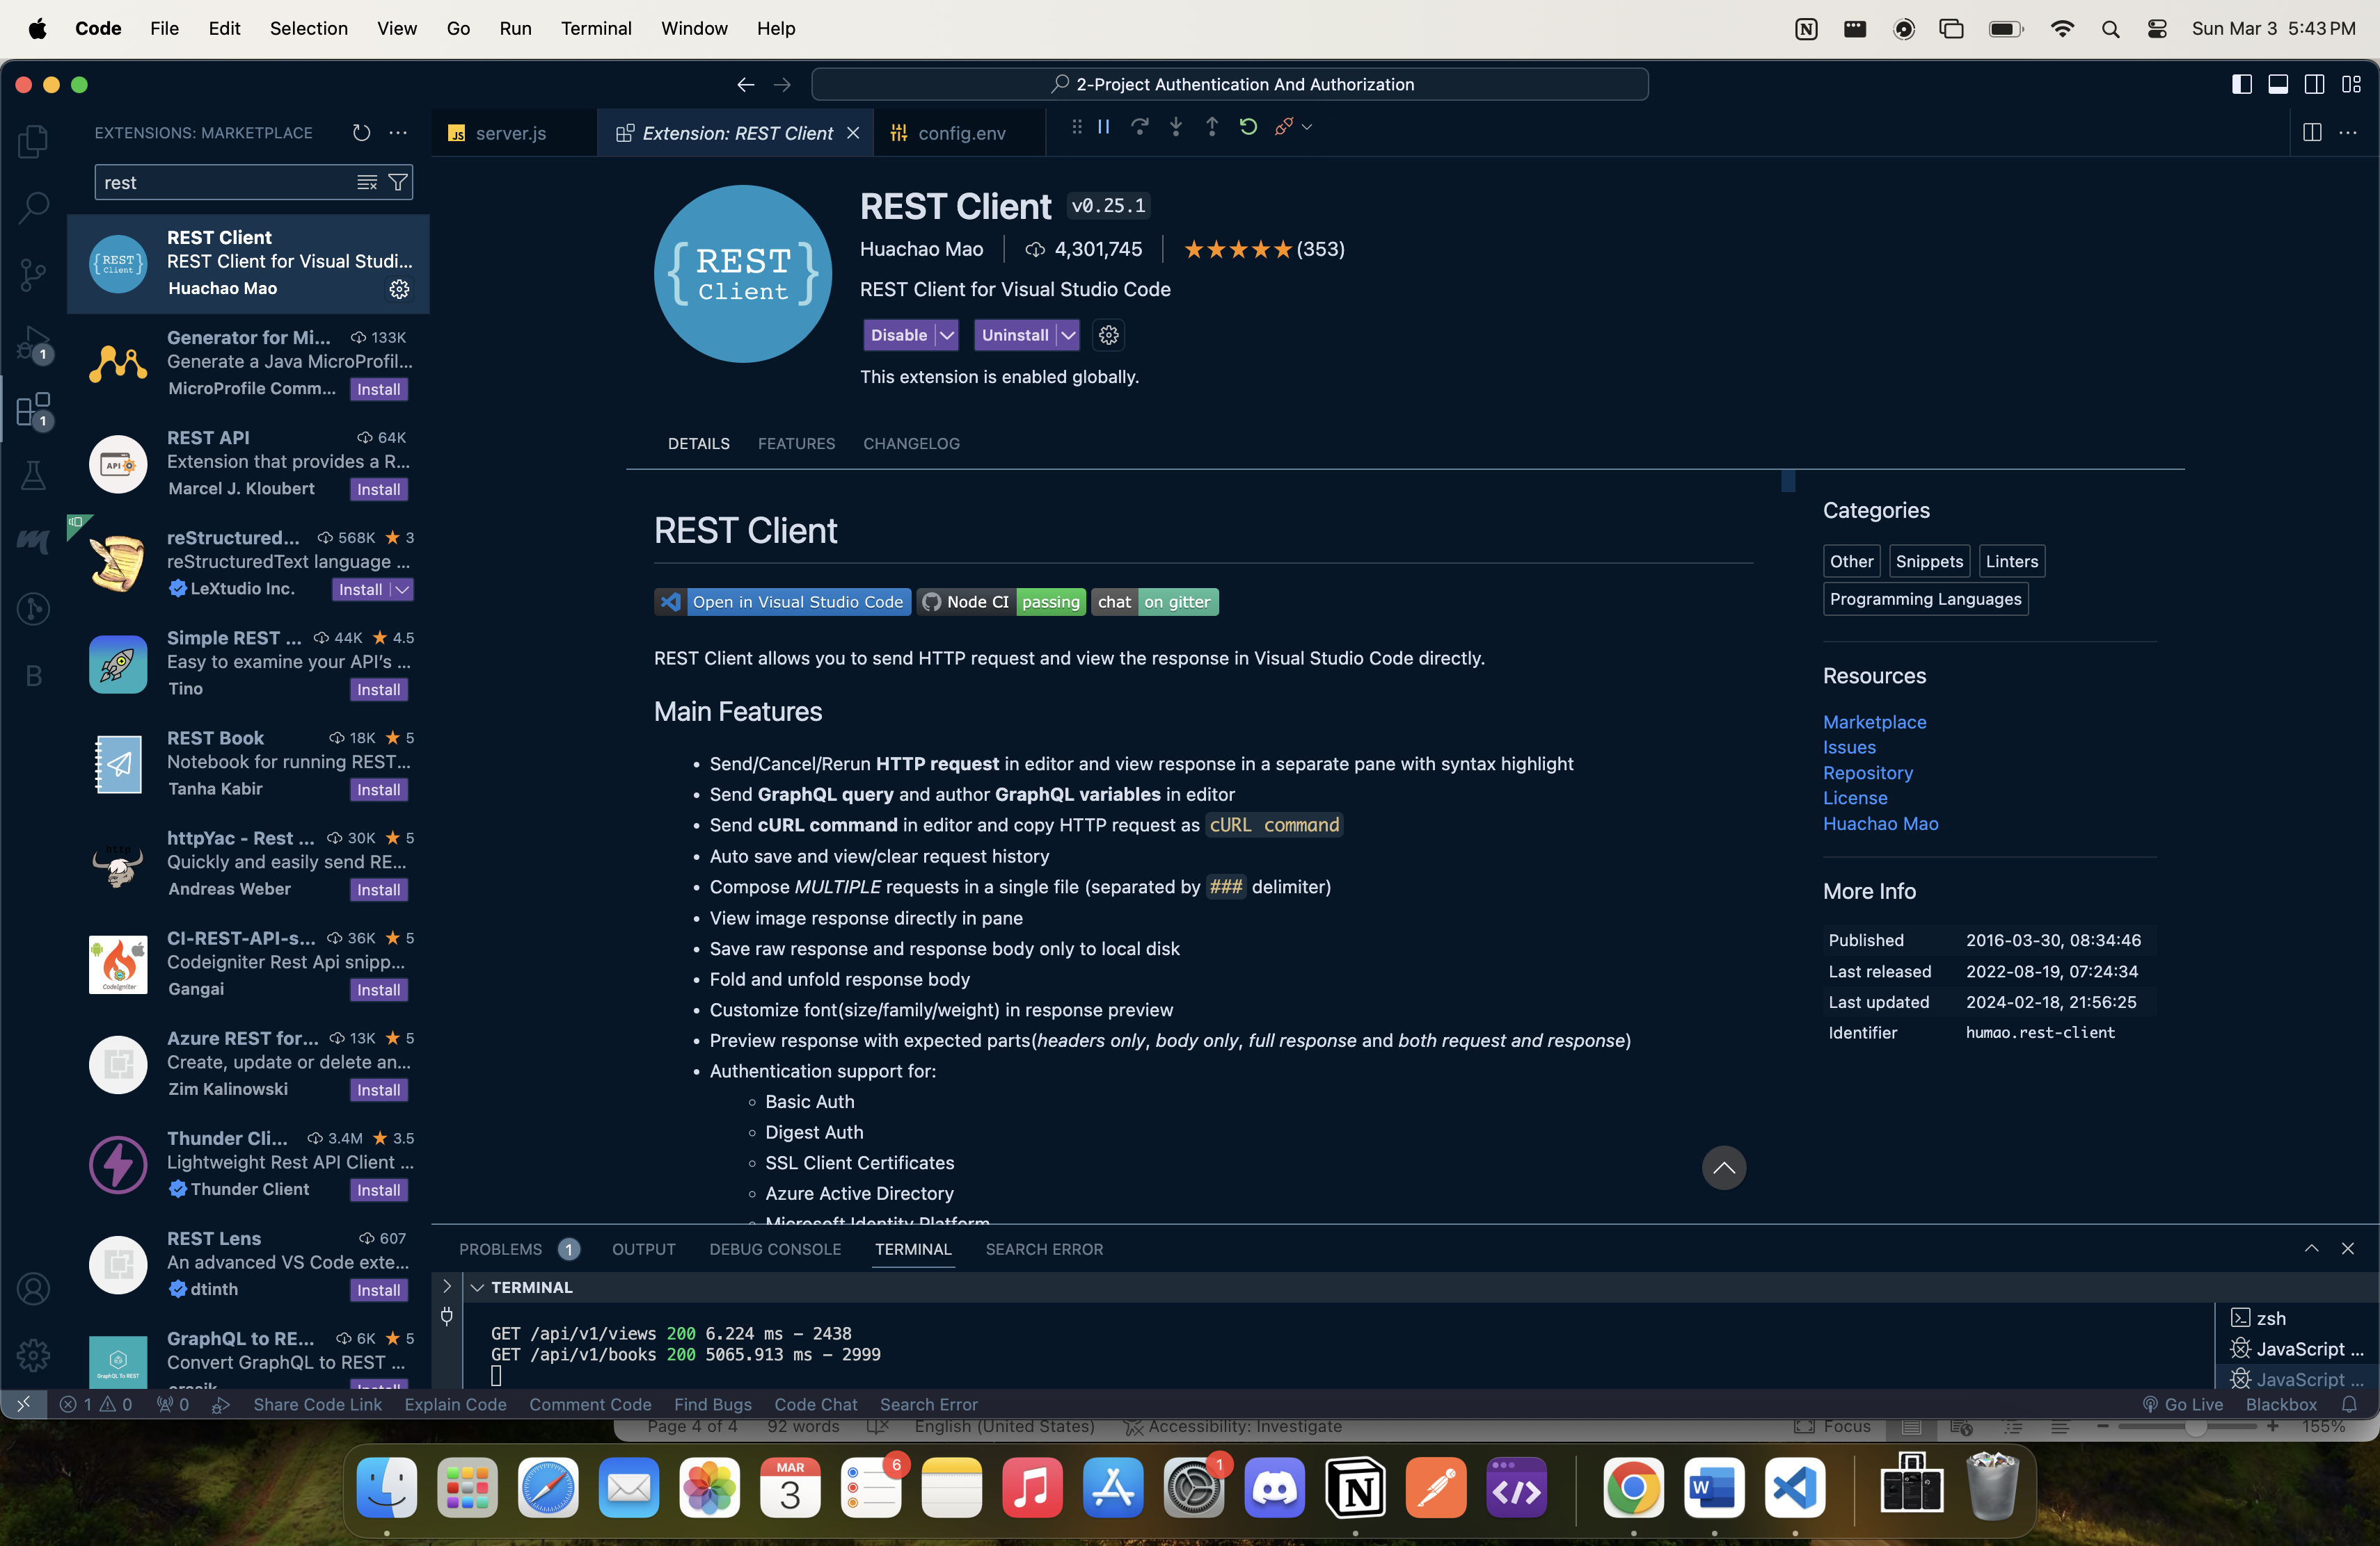

1. **Screenshot Requirement**: Screenshots of all requests and corresponding responses in the REST Client.

